FENCE CONSTRUCTION PROJECT

PROGRESS REPORT

Client:
NDIRANDE HANDICAPPED CENTER
P O Box 60145,
Ndirande,
Blantyre,
Malawi.

Prepared by:
Happy Tembo
Project Consultant (Engineer)
Precious Real Estate Consulting
P.O. Box 2618,
Blantyre.

28 May, 2020
Progress to date
The project has progressed in a satisfactory manner as no major delays were encountered. A month has now elapsed from the time the contract was signed between the successful contractor and the center. This means that two months are remaining for the project to be fully finished. It should be noted that with the availability of contract sum, the project can be finalized within the second month of the contract. The contractor has deployed a good working strategies which are contributing to the steady progress of the work.
During the first month, the contractor has managed to mobilize resources (material and human) which were used for the following planned project activities:
- Excavation of the foundation trench
- Concrete slab (footing) around the fence perimeter
- Foundation wall
- Backfilling of excavated materials (soil)
- Raising of fence walls (in progress)
Currently, the contractor is engage in the construction of superstructure (raising the fence walls). As of today, 28 May 28, 2020 about 50m of the wall was completed with a recommended height of about 2.1m
Below are the progress pictures to date: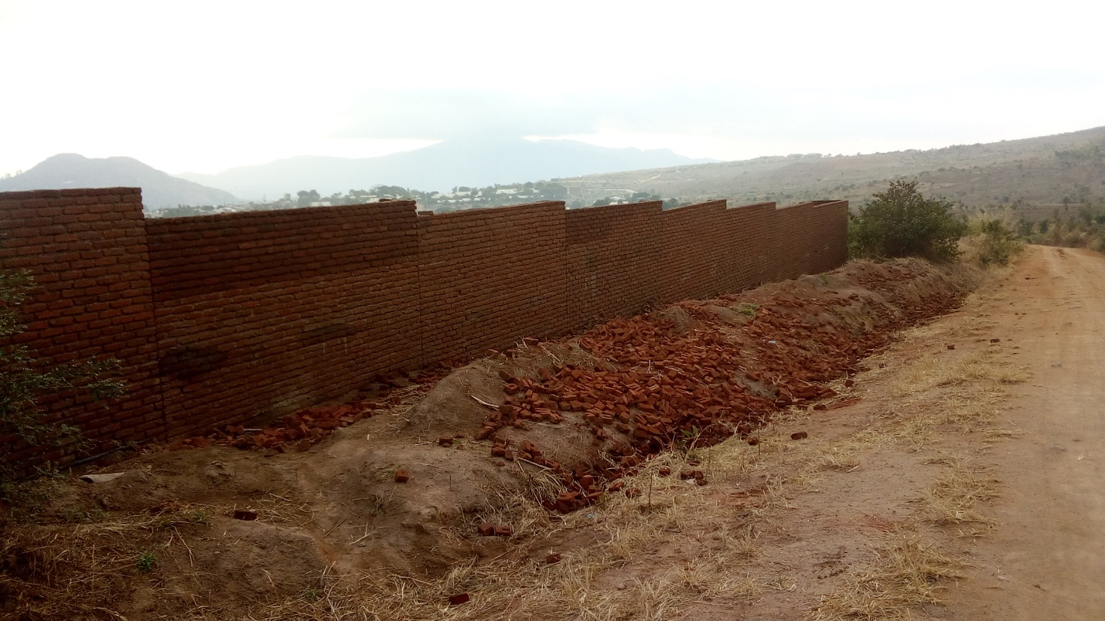
Picture 1: part of completed section of the fence

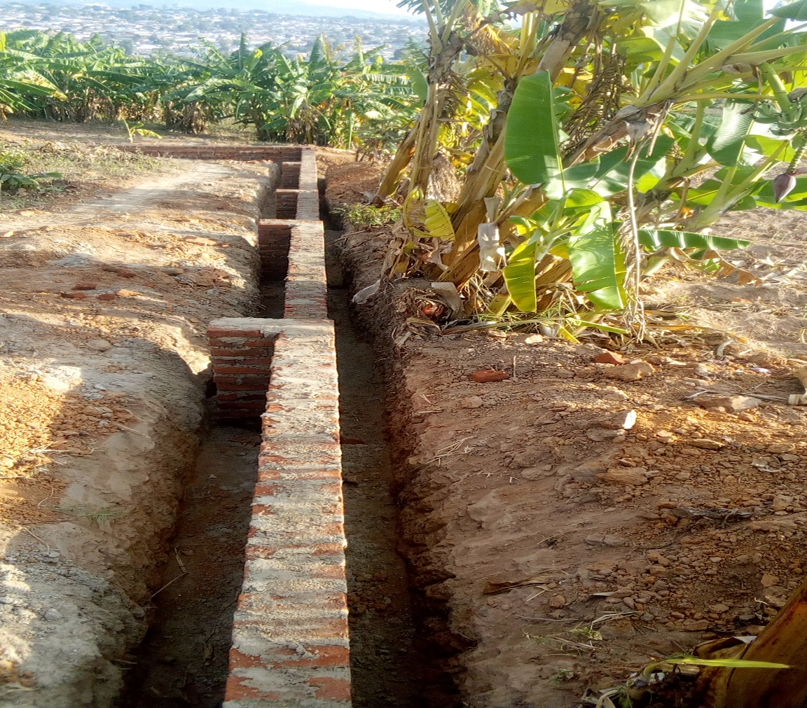
Picture 2: part of the foundation footing and wall

In conclusion, on the engineering point of view (qualitatively and quantitatively), I would say that the project is progressing as required and if the flow of project funds can be continuous as it has been thus far, the project is going to finish in good time. Another thing worth to note is that of coordination between the involved parties, it has really been great which has contributed to the steady progress of the project.

